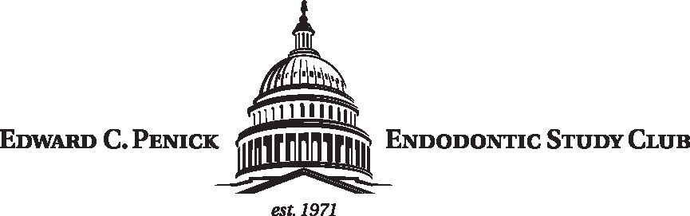
13 September 2023
Edward C. Penick Endodontic Study Club Officers 2023-24
President: Dr. Susan Hinman
VP / Program Chair: Dr. Mary Ann Choby
Treasurer: Dr. Julian Moiseiwitsch
Secretary: Dr. Ricardo Bernandes
Immediate Past President: Dr. Julian Moiseiwitsch
Webmaster: Dr. Gary Goodell
The Officers of the Penick Endodontic Study Club would like to welcome you to another year of exceptional continuing education. The Penick is one of America’s oldest and largest endodontic study clubs. This year’s program will continue the tradition of offering exceptional speakers delivering up to 10 hours of CE and provide opportunities to connect and network with a diverse group of professionals.
Please save the dates for this year’s program:
Date: 12 October 2023
Speaker: Dr. Chin-lo Hahn
Topic: Reflections on Current Cleaning & Shaping Methods

Date: 02 November 2023
Speaker: Dr. Meetu Kohli
Topic: Endodontic Microsurgery – Clinical Considerations

Date: 04 January 2024
Speaker: Dr. Pierre Wohlgemuth
Topic: The Aesthetic Aspect of Endodontic Surgery, from Flap design to Sutures

Date: 21 March 2024
Speaker: Dr. Frederico Martinho
Topic: TBD

Date: 4 April 2024
Speaker: Endodontic Residents’ Table Clinics and Research Posters
Topic: Various

Meeting Location:
Maggiano’s Little Italy
Chevy Chase Pavilion
5333 Wisconsin Avenue NW
Washington, DC 20015

Meeting Schedule:
- 5:30 – 6:00 p.m: Cocktail ½ Hour
- 6:00 – 6:30 p.m: Dinner & Business Meeting
- 6:45 – 8:30 p.m: Lecture
- 8:30 – 8:45 p.m: Q & A

Membership:
Dues: Regular members - $300 Students / Residents - $175
Dues must be paid electronically or via mail prior to the first meeting. Dues cover the cost of all CE and include meals and non-alcoholic beverages for meetings (a cash bar will be available).
Dues Payment:
Please be sure to include your first and last name as well as email address with all forms of payment to be added to the active member roster.
Preferred:
Zelle Account Information:
Name: Penick Endodontic Study Club
Email: Drm@dcendodontics.com
Phone: (202) 255-5056
Personal Check:
Julian Moiseiwitsch
5225 Wisconsin Ave NW
Suite #303
Washington, DC 2001
Alternatively, you may go back to the Penick Membership Application Page on this website to update your membership information for the 2023-2024 year and submit with your remittance to Dr. Moiseiwitsch per the same directions.
CE Credits:
Attendance will be documented at each meeting. It is the responsibility of each member to follow the prescribed procedure for confirming attendance at each meeting. Declarations of attendance following the meeting will not be accepted. Members will receive one electronic form after the final Penick Study Club Meeting that will list all meetings attended and the total corresponding CE credit hours earned.
Meeting announcements and information: Up-to-date information will be posted on the Edward C. Penick Endodontic Study Club website: www.penickstudyclub.com and on the Penick Endodontic Study Club Facebook page. Meeting notices and meal selection requests will be emailed to all members the week prior to a scheduled meeting..
If you have any questions please contact the Penick Secretary at: penickendo@gmail.com . We look forward to another outstanding year of the Edward C. Penick Endodontic Study Club!
Kind regards,
Dr. Susan Hinman

